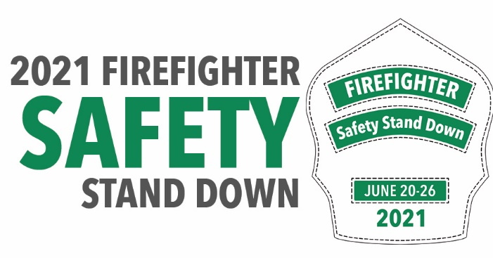

Safety Stand Down 2021: Rebuild Rehab
Departments advised to suspend all non-emergency activities during the week of June 20-26

Firefighting puts intense strain on firefighters, both physically and mentally. It is critical that firefighters receive a comprehensive rehab program after fire incidents or intense training to ensure their physiological and psychological wellbeing. To address this issue, the theme of the 2021 Safety Stand Down campaign is “Rebuild Rehab.”

Sponsored by the International Association of Fire Chiefs (IAFC) Safety, Health and Survival Section, the National Volunteer Fire Council (NVFC), and the National Fire Protection Association (NFPA), this year’s Safety Stand Down will take place June 20-26 and call attention to the need for physical and psychological rehab.

Rehab frequently does not get the consideration it deserves. Many think simply providing food and beverages to firefighters constitutes a rehab program. The 2021 Safety Stand Down challenges departments to reframe their thinking around rehab to mitigate all of the impacts of firefighting and make sure everyone is ready to respond to the next emergency. Rehab should encompass all areas of post-incident health, including cardiac, nutrition, exposure, mental health, hydration, and heat stress.

Responder agencies are encouraged to suspend all non-emergency activities during the week of June 20-26 in order to focus on training and education related to this year’s theme. An entire week has been scheduled to ensure that all shifts and personnel can participate and access the topical information, training, and resources that are available at www.safetystanddown.org. The site will be updated periodically with new tools and resources leading up to Safety Stand Down so that departments can plan their education and awareness activities.

The NFPA will once again host the Fire Service Safety Stand Down Quiz to raise awareness and foster a greater understanding of this year’s theme. Everyone who completes the online quiz will be automatically entered into a sweepstakes; 200 randomly selected participants will win a commemorative Safety Stand Down challenge coin.

Safety Stand Down is supported by national and international fire and emergency service organizations, including the Fire Department Safety Officers Association.

###

About the International Association of Fire Chiefs (IAFC)
The IAFC represents the leadership of firefighters and emergency responders worldwide. IAFC members are the world's leading experts in firefighting, emergency medical services, terrorism response, hazardous response, natural disasters, search and rescue, and public safety legislation. Since 1873, the IAFC has provided a forum for its members to exchange ideas, develop professionally and uncover the latest products and services available to first responders. Learn more at www.iafc.org.

About the National Volunteer Fire Council (NVFC)
The NVFC is the leading nonprofit membership association representing the interests of the volunteer fire, EMS, and rescue services. The NVFC serves as the voice of the volunteer in the national arena and provides critical resources, programs, education, and advocacy for first responders across the nation. Learn more at www.nvfc.org.

About the National Fire Protection Association (NFPA)
Founded in 1896, NFPA is a global self-funded nonprofit organization devoted to eliminating death, injury, property and economic loss due to fire, electrical and related hazards. The 125-year-old association delivers information and knowledge through more than 300 consensus codes and standards, research, training, education, outreach and advocacy; and by partnering with others who share an interest in furthering the NFPA mission. For more information, visit www.nfpa.org. All NFPA codes and standards can be viewed online for free at www.nfpa.org/freeaccess.

